**HIGH SPEED NETWORK (IT-316)**

## Security Protocols in IoT

**Under supervision of**

**Mrs. Anamika Chauhan**



**Submitted by**

**Varun Kumar 2K19 / IT / 140**

**Yashit Kumar 2K19 / IT / 149**

**Department of Information Technology, DTU**

**T ABLE OF CONTENTS**

|  |  |  |
| --- | --- | --- |
| **Sno.** | **Content** | **Page no.** |
| **1** | Paper - 1 ( Security Protocols for IoT ) | 3 - 14 |
| **2** | Paper - 2 ( Security trends in Internet of Things: a survey ) | 15 - 18 |
| **3** | Paper - 3 ( Current research on Internet of Things (IoT) security: A survey ) | 19 - 26 |
| **4** | Paper - 4 ( An Overview of Security in Internet of Things ) | 27 - 30 |
| **5** | Paper - 5 ( ENHANCING SECURITY IN IoT PLATFORM USING SECURE AUTHENTICATION PROTOCOL ) | 31 - 36 |
| **6** | Paper - 6 (IoT Network Security: Threats, Risks, and a Data-Driven Defense Framework) | 37 |

# Research Paper - 1

##### **Title** - Security Protocols for IoT

**Authors** - J. Cynthia, H. Parveen Sultana, M. N. Saroja and J. Senthil

**Link :**

[https://www.researchgate.net/publication/328078416_Security_Protocols_for_](https://www.researchgate.net/publication/328078416_Security_Protocols_for_IoT)

[IoT](https://www.researchgate.net/publication/328078416_Security_Protocols_for_IoT)

**Published** : January 2019

**Abstract** -

Internet of Things (IoT), a network of unambiguously identifiable devices associate degreed embedded package required to attach temporary devices and information unremarkably accustomed activate an mechanism. Edge network devices and protocols area unit accustomed communicate with a cloud server that processes and integrates massive amounts of information from varied devices, performs statistics and resources in business choices. IoT has become associate degree integral a part of fashionable industries, agriculture, health care and sensible town transformation. protective all organisations concerned within the IoT network is vital because it includes comprehensive information assortment and distribution.

Current IoT protocols work with science protocols because the backbone, however area unit specifically designed to figure with multiple layers and supply protection for a spread of layers. This chapter focuses on IoT protocols associated with IoT network security. the largest challenges in accessing the IoT network area unit the shortage of configuration at the assembly level that exposes hardware, package and information to varied threats and attacks. IoT agreements ought to address security breaches on the location of a cloud service supplier and security problems associated with information privacy, authentication, authorization and trust management during a big selection of distributed locations. This chapter conjointly explains very well the assorted security attacks and solutions offered by IoT protocols.

##### **Keywords** IoT security · IoT architecture · IoT protocols · IoT threats IoT attacks · Heterogeneous

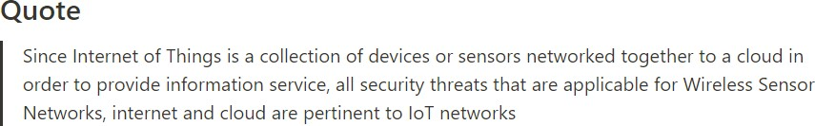

**Key points**

* There area unit over billions of net of Things (IoT) devices, business method associate degreed systems with an IoT component in it
* IoT devices area unit sorted as sensors that collect knowledge, Actuators that result actions and gateways that act as interface for communication and automation
* The success of IoT lies in distributed knowledge gathering, aggregation, process and analytics that may be performed from any location and is typically done as a cloud service
* IoT system evolves with flow of {information} from the detector from wherever it's non

inheritable to the service that processes and performs analytics on the info non inheritable to the client or business that creates use of the analytics information

* Since IoT may be a assortment of devices or sensors networked along to a cloud so as to supply data service, all security threats that area unit applicable for Wireless detector

Networks (WSN), net and cloud area unit pertinent to IoT networks

* Encryption—Strongest associate degreed latest encoding is suggested for an IoT network, if it's cheap

**SYNOPSIS**

**The Internet of Things (IoT) is an emerging technology that has the potential to transform the way we work, live, work and interact with the world around us.**

The success of IoT lies in distributed information gathering, aggregation, process and analytics which will be performed from any location and is typically done as a cloud service. Absence of sturdy authentication of IoT devices, encoding of IoT information, key management, etc., makes AN IoT network at risk of external attacks and threats. There area unit over billions of net of

Things devices, business processes ANd systems with an IoT component in it. Since IoT may be a assortment of devices or sensors networked along to a cloud so as to produce data service, all security threats that area unit applicable for Wireless detector Networks, net and cloud area unit pertinent to IoT networks.

IoT systems evolve with the flow {of data|of knowledge|of data} from the detector from wherever it's non heritable to the service that processes and performs analytics on the information non heritable to the client or business that creates use of the analytics information. Since IoT may be a assortment of devices or sensors networked along to a cloud so as to produce data service, all security threats that area unit applicable for Wireless detector Networks (WSN), net and cloud area unit pertinent to IoT networks. Absence of sturdy authentication of IoT devices, encoding of IoT information, key management, etc., makes AN IoT network at risk of external attacks and threats

**IoT Security Requirements**

* Shipley ANd Jing et al lists security necessities to be checked at numerous stages of the life cycle so as to alleviate an IoT attack.
* Cryptographic Algorithms—Symmetric algorithms area unit light-weight weight compared to uneven algorithms and were counseled for securing information transmission.
* They have issues in key exchange, conﬁdentiality, digital signature and message authentication.
* – style a security feature that protects viewing and piece of writing of knowledge supported its classiﬁcation level.
* Trusted ANd staged boot sequence—A trusty staged boot sequence can guarantee security of an IoT device.
* The OS ought to be designed therefore on have solely the parts, packages ANd libraries needed for running an IoT device.
* No sensitive credentials like passwords area unit to be hold on in logs

**IoT Security Issues**

* The issues related to security of IoT area unit the problems connected with security of wireless medium, WSN and web, and access management, authentication and privacy problems related to IoT.
* Authentication ensures the validity of the info that ﬂows through the device and authorization ensures secured access management.
* The entities in associate degree IoT network is also further dynamically and identity management with authentication becomes even harder.
* The information ﬂow to the central authority follows a hierarchical pattern
* This has higher centralised security management however once subjected to vulnerability, the complete system is compromised.
* In a distributed IoT network each entity is entitled to try and do the task of knowledge assortment, processing, associate degree analysing and distributing data and is an attack vector.
* The edge intelligence at the service provider’s ﬁnish to question the data by a neighborhood user while not intervention from any external entity encompasses a potential vulnerability that ought to be controlled by providing sturdy authentication and authorization options.

###### IoT Security Challenges

* Hossain et al lists the challenges of IoT security supported limitations of hardware, software, network connections.
* The hardware limitations area unit, machine and energy constraint, memory constraint and tamper resistant packaging.
* Limitations on package area unit embedded package constraint and dynamic security patch.
* Limitations on network connections area unit quality, quantiﬁability, multiplicity of devices and communication medium, multi protocol networking and topology

###### IoT Hardware

* IoT hardware includes sensors, wearable devices, digital gadgets, microcontrollers like Arduino, Raspberry pi and embedded hardware.
* IoT hardware devices ar gift with the shoppers, embedded in another device and should be used as a wearable device or is also gift connected to the net all time.
* These devices ar a lot of susceptible to security attacks and may be tampered with.
* Hardware device makers ar a lot of involved with the look side of IoT devices instead of the protection side.
* Due to the prevailing presence of IoT hardware it's troublesome to supply a computer code patch for security updates.
* IoT hardware is exposed to attacks to that all net connected devices ar exposed like DOS, and DDoS.
* Evaluation to be done to see however troublesome it's to vary the credentials hold on in hardware

###### IoT Software and Firmware

* IoT code parts embody the embedded code, operational systems utilized in IoT like mechanical man and small OS, and cloud code like Nimbis and Hadoop.
* IoT devices connected to the net have operational systems embedded as computer code.
* These operational systems don't seem to be designed with security considerations and are at risk of malware attacks.
* The embedded information in appliances, mobile phones and wearable devices with networking capability are additional at risk of external attack.
* This is as a result of they share {the information|the info|the information} with alternative connected devices and also the embedded data lives for additional amount than the hardware themselves.
* The most price effective answer for shielding the embedded code is to watch and secure the trafﬁc at the entranceway.
* Outdated software and code while not a patch should be avoided to make sure security

###### Insecure Network Communication

* Owing to the large range of IoT devices connected to the network, ancient network security, identity and key management mechanisms are troublesome to implement.
* It is troublesome to bring the whole IoT device connected below the boundary of a controlled ﬁrewall, as a result of Associate in Nursing aggressor might use one compromised node to attack the whole network during a lateral manner.
* A mesh network is made by connecting wireless devices with none infrastructure.
* Meshing in IoT allows the IoT components to speak amongst themselves in absence of fastened infrastructure for communication.
* This is extraordinarily helpful just in case of low power and low rate applications in health care, industrial and residential automation applications.
* IoT network in Associate in Nursing enterprise is subjected to vulnerability, if correct Enterprise quality Management (EMM) policy isn't outlined to mitigate the danger of important company knowledge leaked to the surface world

###### Data Leaks from Cloud

* Data is hold on in an exceedingly cloud with the ﬁrst motive of sharing.
* Authenticated sources within the Access management List are expected to access the information.
* A service supplier is liable for any knowledge escape from the cloud.
* A misconﬁgured cloud can result in knowledge escape.
* External access to sensitive knowledge and logs should be restricted.
* A hostile worker could gain access to any internal server and enterprises, source sure services with potential threat of information leak.
* Cloud atmosphere demands continuous watching and intrusion detection.
* It needs watching and work virtual machine logs and shared services.
* Intrusion detection and hindrance systems ar counseled for cloud so as to avoid knowledge escape

###### Threats and Attack Vectors

* The paper indicates a listing of potential threats employed by associate degree IoT targeted wrongdoer.
* The attack vectors ar ways employed by a hacker to realize access to a secured system
* Since IoT devices are exposed to active attackers, it results in DoS form of attack.
* An active wrongdoer might capture a node exposed to an out of doors setting to realize access to the shop information.
* Controlling IoT entity—An active wrongdoer might gain management over associate degree IoT entity through associate degree attack path
* This type of attack gains management of the information and also the services that are related to the information.
* IoT Request Forgery—An wrongdoer tries to focus on IoT devices connected to a company network instead of to crack many security layers.
* Virtualization threats—The host machine running virtualization package may well be attacked by code in a very virtual setting that simulates man within the middle attack.

###### IoT Protocol Architecture

* Most of the IoT security protocols square measure designed to work in multiple layers to supply security.
* Wireless Hart could be a security protocol that operates in multiple layers mistreatment multiple keys and secures the trafﬁc by encrypting payload and providing message authentication.
* LoRaWAN is that the long vary variant that has secured duplex communication, quality and localization services.
* As represented it illustrates the protocols operative altogether ﬁve layers of TCP/IP protocol Stack, the IoT applications and associated services.
* Low power Wide space Network (LPWAN) is employed in IoT for transmission of tiny knowledge over long vary with battery potency.
* It uses modulation techniques like ultra-narrow band, slim band and wide band.

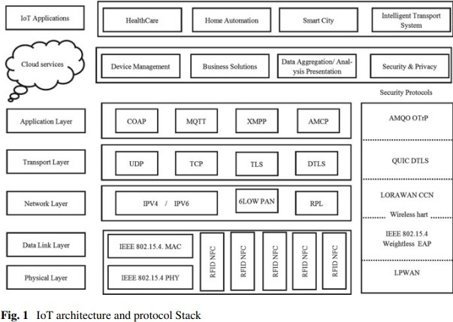

###### IoT Security Attacks

* The Internet of Things, the increasing want in our day-after-day life has a lot of beneﬁts. The vital factor regarding IoT is, it makes the items beings intelligent by embedding sensors and actuators.
* This will facilitate the hacker to attack the information from the cloud and misuse it
* In this means, the protection in IoT is taken into account to be a lot of vital.
* What could also be the question is sometimes, folks can store knowledge solely in their mobile phones, why is there a desire to shield sensing element devices and different home appliances?.
* The factor is, once a tool, say a security camera connected to a house is attacked, the hacker will clearly understand the likelihood of robbing a house.
* When an easy device is attacked, the hacker will gain access to devices that contain secure knowledge
* This is the rationale why security is taken into account to be vital in IoT.

###### Attacks on Firmware

* Firmware is nothing however software package accustomed management hardware devices.
* In the early 90's itself, the computer code attack started.
* Hackers typically add some malicious code to the current non-volatile memory and build it as a section of computer code and begin dominant the device.
* Another reason why individuals like computer code attacks is, they're more durable to observe since they run before the antivirus program starts.
* Hackers attack computer code for 3 main reasons .
  1. Persistence: Malwares are {often|will be|is|may be} cleared often victimisation antivirus software package, whereas computer code isn't Hackers attack computer code for 3 main reasons
  2. Persistence: Malwares are {often|will be|is|may be} cleared often victimisation antivirus software package, whereas computer code isn't.
  3. Protection: Mechanisms like antivirus software’s won't examine computer code so it are often hidden and used for an extended time.
  4. Authorization: Being a section of computer code by adding malicious code, the user will get complete authorization for accessing the system.

###### Authorization

* Being a section of computer code by adding malicious code, the user will get complete authorization for accessing the system.
* Most of the folks area unit unaware regarding change device software system.
* Do you suppose that the newest computer code can give complete security?
* Most of the devices that area unit factory-made recently area unit equipped with the OS that was a decade past.
* It was not maintained by Security professionals which ends up in easier attacks.
* Is it not necessary to update the software?
* The shoppers will demand the makers to produce higher security devices.
* This can be done only IT professionals, trade and security specialists work along

###### Attacks on Data

* Being a section of computer code by adding malicious code, the user will get complete authorization for accessing the system.
* Most of the folks area unit unaware regarding change device software system.
* Do you suppose that the newest computer code can give complete security?
* Most of the devices that area unit factory-made recently area unit equipped with the OS that was a decade past.
* It was not maintained by Security professionals which ends up in easier attacks.
* Is it not necessary to update the software?
* The shoppers will demand the makers to produce higher security devices.
* This can be done only IT professionals, trade and security specialists work along

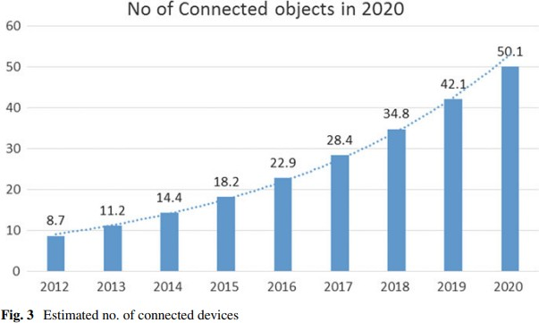

###### TELNET Based Attacks

* This is a vital topic in IoT. individuals can suppose Telnet is incredibly previous and what's vital in it.
* If AN aggressor will notice a open telnet port, he will perform the following:
* One example of this sort of attack is that the Bricker larva attack.
* Bricker larva attack was designed to record the primary tried username and word.
* The attack may be blocked by disabling Telnet and dynamic the default passwords.
* Another reason why telnet is vital is most of the devices are going to be having default username and passwords.
* Even though individuals victimisation the devices square measure educated to vary the passwords, it's not clear that everyone will identical.
* Such devices may be supplied with remote access through Telnet and SSH

###### DDOS Attack

* Denial of Service Attack is another vital attack within the case of web of Things. Denial of Service attack generates additional trafﬁc to the server and overloads it which ends up within the service being rejected.
* According to a tweet from OVH founder Octave Klaba on twenty two Gregorian calendar month 2016, a synchronous DDoS attack of 990 Gbps was launched by a botnet consisting of over a hundred forty ﬁve,000 compromised IoT devices (IP cameras and DVRs).
* A Botnet could be a logical afﬁliation of compromised devices like routers, smartphone or IoT devices
* These compromised devices is controlled and used for activity DDoS attacks.
* Mirai malware is meant to scan the web for insecure connected devices, whereas avoiding information science addresses happiness to major companies, like HewlettPackard and government agencies, like the U.S Department of Defense
* Once it identiﬁes associate degree insecure device, the malware tries to log in with a series of common default passwords utilized by makers.
* The Mirai ASCII text ﬁle was later discharged to the general public, permitting anyone to use the malware to compose botnets investment poorly protected IoT devices

###### Malware

* Malware is once more computer code wont to gain access to a tool and infect them. Most of the IoT attacks ar performed either by employing a malicious program program or malware.
* According to a report provided by Kaspersky research laboratory, quite eight.5 million malware attacks are performed throughout 2015 and 2016.
* Why ar these devices therefore susceptible to malware infection?
* Limited upgrade capabilities: cheap devices, like several IoT product, usually have terribly low-proﬁt margins, which might build it troublesome or perhaps not possible for makers to afford to update code or send security patches.
* By ﬁnance an inexpensive quantity of your time and energy to thwart IoT malware businesses are going to be far better ready for the ever-increasing variety of vulnerable devices that may sure as shooting be connecting to their networks

###### IoT Security Solutions

* Here concisely mentioned the potential attacks that may be performed on AN IoT device.
* We will discuss the protocol stack of IoT design, varied protocols that support the design and therefore the varied solutions to reinforce the protection of IoT devices.
* It is a challenge to use science algorithms which regularly would like additional resources than the small devices have all at once.
* Another challenge is change devices within the ﬁeld.
* There is typically solely AN unreliable afﬁliation offered and security essential things incorporate immediate updates, which might be tough to roll bent on all

###### Transport Layer Solutions

* The transport layer in the main involves 2 styles of protocols. One is transmission control protocol and another one is UDP.
* In addition to those protocols, alternative protocols like Secure Socket Layer, Datagram Transport Layer Security and fast UDP web Connections square measure explained to transient regarding the protection in transport layer

###### Transmission Control Protocol (TCP)

* TCP is one among the wide used transport layer protocols wherever reliableness could be a major concern.
* TCP works on the principle of 3-way handclasp method.
* It has a association institution section, knowledge transmission section and association termination section.
* It determines the way to break the appliance knowledge into packets such the network layer will method.
* In this header, we've a separate ﬁeld, speciﬁcally check to make sure whether or not the received knowledge is correct or not.
* We have to separate ﬁelds, speciﬁcally check to make sure whether or not the received knowledge is correct or not.

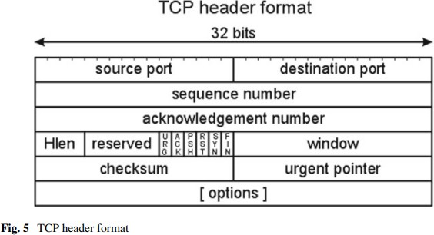

###### Secure Socket Layer (SSL)

* In order to transfer personal knowledge, SSL has been introduced.
* When an internet browser tries to attach to a web site victimization SSL, the browser can 1st request the online server to spot itself.
* This prompts the online server to send the browser a duplicate of the SSL Certiﬁcate.
* The server responds to the browser with a digitally signed acknowledgement to begin associate SSL encrypted session.
* This allows encrypted knowledge to be shared between the browser and therefore the server.
* Even though SSL provides security, it's still susceptible to Man-in-the middle attacks.
* To overcome the issues with SSL, we tend to move to TLS

###### Transport Layer Security (TLS)

SSL, or Secure Sockets Layer, is that the forerunner to TLS, or Transport Layer Security. TLS could be a protocol that has privacy and knowledge integrity between 2 act applications. TLS and SSL don't seem to be practical, tho' TLS presently provides some backward compatibility so as to figure with inheritance systems. TLS isn't liable to the dog attack, as a result of it specifies that each one cushioning bytes should have constant price and be verified, a variant of the attack has exploited sure implementations of the TLS protocol that don’t properly validate secret writing cushioning. This makes some systems liable to dog, though they disable SSL—one of the counseled techniques for countering a dog attack. The IETF is functioning on the problem and still it's a draft.

**User Datagram Protocol (UDP)**

In distinction to transmission control protocol, yet one more protocol specifically UDP has been designed. it's no handclasp dialogues, and exposes the user’s program to any undependableness of the underlying network protocol. UDP provides checksums for knowledge integrity, and port numbers for addressing totally different functions at the supply and destination of the datagram. compared with transmission control protocol, UDP is most popular for IoT devices because of bottom overhead. In several resource-constrained embedded styles, UDP’s lack of overhead makes an enormous distinction in outturn compared to transmission control protocol. as a result of a UDP dealings needs solely 2 UDP datagrams, one in every direction,

load on the network is minimised, more reducing response times.

**Datagram Transport Layer Security (DTLS)**

* DTLS could be a protocol that has security for datagram-based applications by permitting them to speak in a very approach that's designed to forestall eavesdropping, tampering, or message forgery.
* DTLS consists of 2 layers: the lower layer contains the Record protocol and therefore the higher layer contains any of the 3 protocols speciﬁcally shake, Alert, and alter Cipher speciﬁcation, or application knowledge.
* The amendment Cipher speciﬁcation is employed throughout the shake method to simply indicate that the Record protocol ought to shield the next messages with the freshly negotiated cipher suite and security keys.
* The Record header contains among others content sort and fragment ﬁelds.
* Based on the worth within the content sort, the fragment ﬁeld contains the shake protocol, Alert protocol, amendment Cipher speciﬁcation protocol, or application knowledge.
* The Record header is primarily accountable to cryptographically shield the higher layer protocols or application knowledge once the shake method is completed.
* The DTLS Record could be a rather easy protocol whereas the shake protocol could be a complicated chatty method associated contains varied message exchanges in an asynchronous fashion.
* The scope of this paper is proscribed to the header compression solely and not the cryptologic process of Record and shake protocols

###### Quick UDP Internet Connections (QUIC)

Quic is another multiplexed stream bound protocol over UDP. Quic is meant to supply security like SSL/TLS. the most goal of this protocol is to enhance the performance compared with transmission control protocol.

**Application Layer Solutions**

* The Internet has been victimization communications protocol protocol for a quite very long time. what's the necessity for alternative protocols? communications protocol is sweet for obtaining info by employing a request-response model.
* IoT devices persevere pushing info to the cloud or servers that it has to send.
* In such a case, communications protocol isn't suited.
* HTTP uses a lot of information measure attributable to the text-based request and response model, that isn't ﬁtted to low power information measure devices.
* Keeping in mind these items, 2 protocols are developed, one is MQTT and another is COAP.
* Another reason for the recognition of those protocols is, they're smaller than communications protocol, designed for machine to machine communications, Quality of Service and tolerant to lossy networks

###### CoAP (Constrained Application Protocol)

* CoAP, forced Application Protocol, the name itself tells that it's associate application layer protocol.
* It is meant for retransmitting the lost packets.
* CON (Conﬁrmable)—when reliableness is needed, use this kind of message.
* The options square measure (i) Observe ﬂag—In communications protocol, it's difﬁcult to understand the unused state on a variable.
* This ﬂag is employed beside the GET message.
* Analogous to TLS protected communications protocol (HTTPs), the DTLS secure CoAP protocol is termed CoAPs. DTLS guarantees E2E security of various applications on one machine by operative between the transport and application layers

###### MQTT (Message Queue Telemetry Transport)

* MQTT could be a TCP-based light-weight protocol that uses publish-subscribe electronic communication pattern.
* Any supply like a detector will publish its knowledge and any consumer will take that knowledge.
* The RETAIN ﬁeld informs the server to retain the last received Publish message
* It uses easy message format, and needs less battery.
* To provide support to the authentication method, it depends on Transport Level Security (TLS).
* The draw back of victimization TLS, SSL, and alternative ways of secret writing is that they will add vital overhead
* Techniques like TLS session recommencement will catch up on a number of the association prices of TLS.
* Both of those shortcomings square measure self-addressed by the MQTT-SN (MQTT—Sensor Networks) protocol, that deﬁnes a UDP mapping of MQTT and adds broker support for categorization topic names

###### Secure MQTT (SMQTT)

* MQTT and MQTT-SN each use SSL/TLS for security. however actually, providing security certiﬁcates to all or any the devices is completely not possible.
* SSL/TLS suffers from attack like BEAST, CRIME etc
* Variable Header contains username and positive identiﬁcation ﬂag, upon setting them, corresponding values square measure enclosed in payload
* These values don't seem to be encrypted within the message and not secure.
* SMQTT protocol augments security feature to the prevailing MQTT by proposing a brand new MQTT Publish message Spublish with reserved message sort ‘0000’, wherever the messages encrypted victimization ABE (Attribute based mostly Encryption).
* (i) Publisher device publishes the info below the given topic.
* (ii) Subscriber device receives the info below constant topic through a Broker.

###### Network Layer Solutions

The devices within the web of Things square measure resource forced devices, which suggests the dimensions of the device; the facility and therefore the memory capability square measure

restricted. It will allot up to 2128 vary of addresses This makes it potential to allot all numbers of devices that square measure connected within the IoT world. albeit IPv6 provides the addressing platform, it's not appropriate for the low power devices concerned in IoT. To support these devices, we'd like another protocol. It will compress IPv6 headers to 2 bytes.

**Research Paper - 2**

**Title** - Security trends in Internet of Things: a survey

**Authors** - Rachit, Shobha Bhatt, Prakash Rao Ragiri

**Link :** <https://link.springer.com/article/10.1007/s42452-021-04156-9>

**Published** : 12 January 2021

#### Abstract -

The Internet of Things (IoT) may be a network of embedded devices that ar unambiguously acknowledgeable and have embedded software package needed to speak between the transient states. the aim of this study is to explore separate IoT security challenges touching on presently deployed IoT standards and protocols. we've got conferred an in depth review during this study that focuses on IoT’s at hand security aspects, covering identification of risks touching on this IoT system, novel security protocols, and security comes proffered in recent years. This work presents AN updated review of the IoT design within the protocols and standards that ar proffered for the next-gen IoT systems. A security-specific comparative analysis of protocols, standards, and proffered security models ar conferred as per IoT security necessities. This study elicits the necessity for standardization at the communication and information audit level, that exposes the hardware, software, and information to varied threats and attacks. Our study reveals a desire for protocols that ar competent enough to be accorded for over one threat vector. This paper provides AN insight into the newest security analysis trends, which can prove helpful within the development of IoT security. The analysis outcomes will profit the analysis community in IoT by desegregation IoT-based devices’ best security aspects.

* The entire network domain is undergoing a forceful age
* To avert the modiﬁcations brought within the web of Things (IoT) devices through physical attacks, there's a provision of Physically Unclonable perform [67] protocols that ar imbibed within the specially designed PUF chip mounted on the IoT devices
* This work highlighted the recent security trends within the IoT network domain by measuring the new proffered models, protocols, and secret writing ways silent in securing the IoT network
* Our analysis ﬁndings on security risks in IoT emphasize the extension of the attack surface of the IoT threats and vulnerabilities in protocol-based and experimental attacks, that conveys the very fact that typical means that are not any longer as economical as they were earlier against dynamic attacks prevailing in heterogeneous IoT environments like malicious node, Distributed Denial of Service (DDoS) attack, and botnet attacks
* Investigations of latest analysis models show that majority of security solutions ar wanted through the implication of different styles of secret writing ways, that have established to be effective in securing channel attack surfaces in IoT and promoting lower energy consumption within the method
* Efforts are created to deal with the evolution of existing communication technologies, protocols, and internationally accepted worldwide standards, relentless efforts that are created by the scientiﬁc researchers globally in antecedent mentioned topics

**Introduction**

Automation of networks has been a hot topic that has been trending for quite your time.

* Supplementing it's web of Things (IoT) technology, that paves the means for providing that component.
* Local physical devices connected to the net for time period information analysis were thought-about being the IoT network.
* Research works on IoT depict the proliferation of IoT within the ﬁeld of–healthcare [3], industrial setup [4], business analytics, education, etc.
* As of 2019, IoT, that wont to work smaller network areas, has upgraded for wide space networks, and then have the risks relative to that owing to the expected surge in IoT devices in a very distributed surroundings

**Objectives**

The purpose of this study is to explore separate IoT security challenges touching on presently deployed IoT standards and protocols

### Methods

Priyanka et al , Munkenyi Mukhandi et al , and Pooja Shree Singh and Vineet Khanna have security provisions for Integrity security necessities, however the model planned by Munkenyi Mukhandi et al having further provisions for legitimacy in Industrial IoT surroundings robotic setups wherever secret writing mechanisms ar integrated mistreatment MQTT protocols.

* Priyanka et al [13] has planned robust cryptographical securing ways to avert the Integrity primarily based attacks.
* Security resolution proffered by Pooja Shree Singh and Vineet Khanna [32] implies MFCC security coefﬁcients to make sure the conﬁdentiality
* Discussion

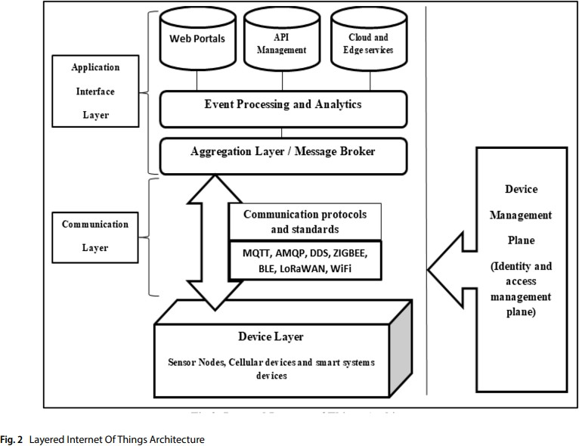

### Discussion

The result derived from the said comparative analysis states that protocol-based security solutions conceal most of the IoT attack surfaces.

* MQTT and BLE, the light-weight protocols, have emerged to produce an efﬁcient resolution against the threats relative to malicious node and Man within the middle attacks.
* Its distinctive authentication mechanism supported the PUFs makes it a formidable choice against threats borne out of physical attacks.
* Based on these protocols and standards, the comparative analysis is projected for the protection models.
* Security models depict the novel usage of secret writing ways, machine learning ways [68], blockchain [69], and socket programming to make sure the conﬁdentiality, integrity, legitimacy, handiness, and trust-based security necessities within the IoT surroundings.
* Divisive security management proves to be helpful for easier management of the protection ways, planned secu- Technique used rity model.

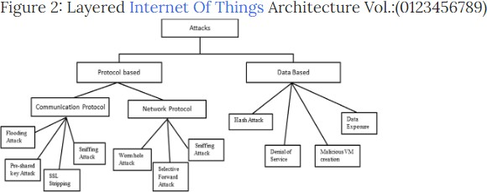

### Conclusion

This work highlighted the recent security trends within the IoT network domain by measuring the new proffered models, protocols, and secret writing ways silent in securing the IoT network.

* Investigations of latest analysis models show that majority of security solutions ar wanted through the implication of different styles of secret writing ways, that have established to be effective in securing channel attack surfaces in IoT and promoting lower energy consumption within the method.
* Integration of technologies like machine learning, artiﬁcial intelligence-based formal logic ways, elliptical cryptographical functions, and blockchain has assisted in ﬁrming the protection of the IoT networks.
* Efforts are created to deal with the evolution of existing communication technologies, protocols, and internationally accepted worldwide standards, relentless efforts that are created by the scientiﬁc researchers globally in antecedent mentioned topics.

# Research Paper - 3

##### **Title** - Current research on Internet of Things (IoT) security: A survey

**Authors** - Mardiana binti Mohamad Noor, Wan Haslina Hassan

**Link :**

[https://fardapaper.ir/mohavaha/uploads/2019/06/Fardapaper-Current-researc](https://fardapaper.ir/mohavaha/uploads/2019/06/Fardapaper-Current-research-on-Internet-of-Things-IoT-security-A-survey.pdf)

[n-Internet-of-Things-IoT-security-A-survey.pdf](https://fardapaper.ir/mohavaha/uploads/2019/06/Fardapaper-Current-research-on-Internet-of-Things-IoT-security-A-survey.pdf)

**Published** : 1 December 2018

**Abstract** - Abstract - The results of IoT failures may be severe, therefore, the study and analysis in security problems within the IoT is of utmost significance. the most objective of IoT security is to preserve privacy, confidentiality, make sure the security of the users, infrastructures, data, and devices of the IoT, ANd guarantee the supply of the services offered by an IoT system. Thus, analysis in IoT security has recently been gaining abundant momentum with the assistance of the offered simulation tools, modellers, and procedure and analysis platforms. This paper presents AN analysis of recent analysis in IoT security from 2016 to 2018, its trends and open problems. the most contribution of this paper is to produce an outline of this state of IoT security analysis, the relevant tools,IoT modellers and simulators.

* The Internet of Things (IoT) is visualized to grow chop-chop due the proliferation of communication technology, the supply of the devices, and procedure systems
* A microgrid IoT system still depends on ancient superior management and information Acquisition (SCADA)
* High quality papers from internet of information were reviewed and classiﬁed into by their objectives, ways utilized in the analysis, and therefore the simulation tools utilized in order to simulate or validate the results
* There is little doubt that the speedy progress of analysis in IoT security is supported by the supply of simulation tools and IoT modellers
* It is assumed that the IoT can stay a target and attack vector for years to come back. this can be thanks to the increasing range of IoT devices, the heterogeneousness of the protocols utilized in the IoT, and therefore the borderline or default security measures embedded within the devices by the makers
* It may be terminated that AN acceptable IoT threat modelling can be helpful in

strategizing effective IoT security mitigation. the aim of this survey has been accomplished by giving AN adequate summary of the analysis trends in IoT security between 2016 till 2018 and therefore the relevant tools and simulators

**Introduction**

* The Internet of Things (IoT) is visualized to grow chop-chop due the proliferation of communication technology, the supply of the devices, and procedure systems.
* As compared to those different surveys, this survey presents ﬁndings on this IoT security mechanisms, together with authentication, encryption, trust management, secure routing protocols, and new technologies applied to IoT security, beside the connected tools and simulators concerned within the analysis
* This survey 2018 Ye s Ye s Ye s Ye s Ye s Ye s Ye s Ye s [7] Elsevier 2018 N o Ye s Ye s Ye s Ye sNoNo Ye s [1] Elsevier 2018 N o Ye s N o Ye s Ye s Ye sNoNo [4] Elsevier 2018 Ye sNoNoNoNoNoNoNo [5] Elsevier 2017 N o N o Ye s Ye s Ye s Ye sNoNo [6] Elsevier 2017 N o N o Ye s Ye sNoNoNo Ye s [2] IEEE 2017 NoNoNo Ye sNoNoNoNo [3] IEEE 2017 NoNoNo Ye s Ye sNoNoNo

**Background**

The IoT design is predicated on a 3-tier/layer system that consists of a perception/hardware layer, a network/communication layer, and a layer of interfaces/services.

* The elements that structure AN IoT system ar hardware/devices, communication/messaging protocols, and interfaces/services.
* Hardware, like the sensors and actuators, contains the foremost necessary parts within the IoT.
* For the hardware software system, IoT devices generally use a true Time software system (RTOS), which incorporates a microkernel, hardware abstraction layer, communication drivers, and capabilities like method isolation, secure boots, and application sandbox.
* Bluetooth, ZigBee, PLC, WiFi, 4G and 5G is also chosen because the communication protocols, to suit the requirements of the IoT processes
* Another necessary element within the IoT is that the individual, which may be the entranceway for AN IoT design, like a local area network router.
* The ability to form all IoT devices available by victimisation IPV6, permits the IoT devices to be connected on to the Cloud

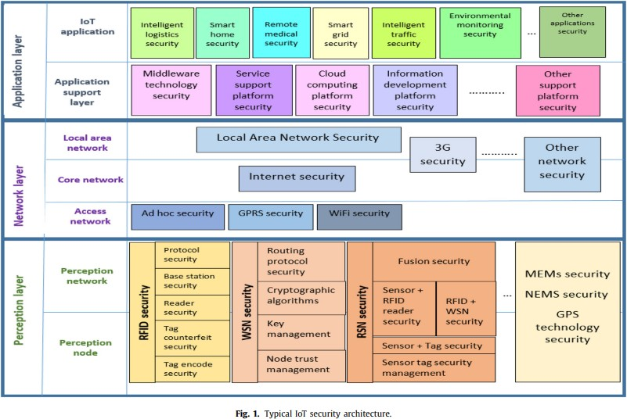

### Introduction to [IoT](https://en.wikipedia.org/wiki/Internet_of_Things) security

Due to the range of the devices ANd multitude of communication protocols in an IoT systems, and varied interfaces and services offered, it's not appropriate to implement security mitigation supported the normal IT network solutions.

* The current security measures that ar applied in an exceedingly typical network might not be comfortable.
* Attack vectors as listed by Open internet Application Security Project (OWASP) concern the 3 layers of AN IoT system, that ar hardware, communication link and interfaces/services.
* Radio Frequency Identiﬁcation (RFID) ANd Wireless sensing element Network (WSN) ar thought-about as a part of an IoT network.

[**IoT**](https://en.wikipedia.org/wiki/Internet_of_Things) [**attack vector**](https://en.wikipedia.org/wiki/attack_vector)**s**

Referring to the IoT security design, IoT security problems ar pertinent in any respect 3 IoT layers.

* Authentication is that the most well-liked security technique to realize secure communication within the network layer.
* Even though there ar problems with inutility thanks to the devices’ constraints, some researchers recommend implementing IPSec within the IoT atmosphere through the difference layer.
* Insecure internet ANd cloud interfaces ar vulnerabilities that will be AN attack vector in an IoT system at the appliance layer.
* Data and sender namelessness Device vulnerabilities sanctioning IPSec communication with IPv6 nodes Conﬁgurable embedded pc systems.
* Securing IoT systems presents variety of distinctive challenges, like unreliable communications, hostile environments, and inadequate protection of knowledge and privileges [9].
* There ar a lot of security challenges at the perception layer
* This may be for many reasons, like straightforward physical access to the tip nodes, vulnerable devices’ internet interfaces, and unsecured network services.
* It may be terminated that for IoT systems, physical devices or the end-nodes ar the most attack surface for the adversaries

### Development of current [IoT](https://en.wikipedia.org/wiki/Internet_of_Things) security mechanisms

The main objective of applying security mitigation is to preserve privacy, conﬁdentiality, making certain the protection of the users, infrastructures, information ANd devices of the IoT and to ensure the supply of the services offered by an IoT system.

* The mitigation and countermeasures ar sometimes applied consistent with the classic threat vectors.
* It is discovered that authentication continues to be the foremost standard technique for security, whereas trust management is gaining quality, thanks to its ability to stop or ﬁnd malicious node.
* Research on coding is concentration on light-weight and inexpensive coding for low-power and unnatural devices

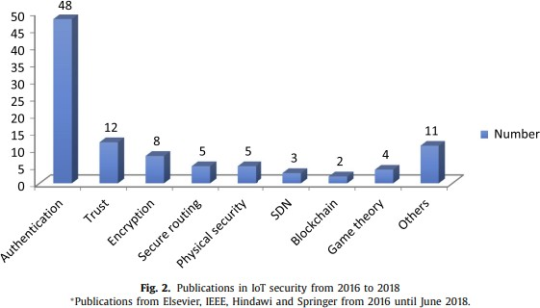

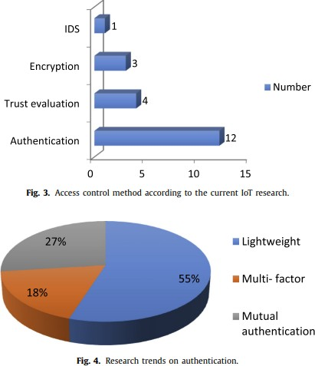

### Authentication

Authentication is that the method of distinctive users and devices in an exceedingly network and granting access to approved persons and nonmanipulated devices.

* As shown within the graph, authentication is presently still the foremost standard technique (60%) to grant access to the user at the appliance layer and provides access to the device within the IoT network.
* For unnatural devices, TLS offers TLS-PSK, that uses pre-shared keys, and TLS-DHE-RSA authentication technique that uses RSA and Difﬁe-Hellman (DH) key exchange, that ar public key and cryptographical protocols.
* In this theme, the 2 entities that ar to perform mutual authentication should prove their legitimacy to every different by sharing secret data beforehand.

### Weaknesses of [IoT](https://en.wikipedia.org/wiki/Internet_of_Things) authentication methods

Due to the [challenges](https://en.wikipedia.org/wiki/Challenges) in an [IoT](https://en.wikipedia.org/wiki/Internet_of_Things) system, such as scalability, constrained devices, heterogeneous protocols and communication channels, applying authentication as a security mechanism may face several [challenges](https://en.wikipedia.org/wiki/Challenges), which are discussed brieﬂy .

* Due to the challenges in AN IoT system, like quantiﬁability, unnatural devices, heterogeneous protocols and communication channels, applying authentication as a security mechanism could face many challenges, that ar mentioned in brief .
* Overhead is reduced Support each mobile and static nodes, mutual authentication Mutual authentication, 3 issue authentication Improve key management and use AES-GCM one pass authentication for information integrity Multi-factor authentication, light-weight biometric identiﬁcation and key agreement Mutual authentication, novel authentication and key agreement supported bio-hashing capability primarily {based}}} access admission management Authentication theme for multi entranceway WSN 3 issue UAKMP extremist weight RFID authentication protocol Use elliptic curve crypto system to come up with bilateral secure key Use NFC and appropriate for mobile atmosphere Interpret users’ biometric signal one-way and duplex IP or non-IP devices 3 issue authentication victimisation bio-hashing Security increased cluster based (SEGB) Parallel matching mechanism and cloud computing based resolution Secure network secret writing signatures light-weight authorization for un-trusted Cloud Platform Bio hashing authentication New signature based authentication key institution Authentication protocol by victimisation positive identiﬁcation Mutual authentication package integrity, mutual authentication and tamper proof feature for sensible embedded object Social networking primarily based} authentication (SNAuth) protocol Identity based AKE protocol No pre organized security data is required offer user namelessness ID-based key sharing theme to TLS Certiﬁcate free authentication

certiﬁcate-less authentication.

* Due to the devices’ resource constraints, the trust analysis is centralized as in several proposals, see Table eight

### Encryption

In achieving ﬁnish to ﬁnish security, the nodes area unit encrypted.

* Due to the nonuniformity of the IoT systems, some nodes may well be ready to imbed general purpose small processors.
* Low resources and strained devices will solely imbed application-speciﬁc ICs .
* Lightweight cryptography is also associate degree economical cryptography for these devices.
* Since the goal for IoT cryptography is to attain economical ﬁnish to ﬁnish communication with low power consumption, radial and uneven light-weight algorithms for IoT area unit designed to satisfy the necessities.
* Research in has focussed on implementing low value and light-weight cryptography within the physical and also the network.

### Trust management

The objective of IoT trust management is to sight and eliminate malicious nodes and to supply secure access management.

* Even though solely 2 hundredth of the access management strategies presently use trust analysis, it's still a promising security mechanism
* This may ensue to its ability to calculate a node’s dynamic trust score.
* Scalability, having the ability to be autonomous, and energy potency area unit necessary for any routing answer
* Some of these device nodes area unit border routers to attach the low power lossy network (LLN) to the net or to an in depth by native space Network (LAN).
* In order to launch a depression, Blackhole or Sybil attack, a malicious node can try and realize the simplest way to participate within the routing or forwarding path of the info and management packets.
* Disrupt routing path massive trafﬁc ﬂows through offender node Route formation through offender node Disrupt the conﬁguration and trafﬁc ﬂow Routing trafﬁc unapproachable to victim node create resources unavailable to meant users Packet delay and management overhead Packet delay, delivery quantitative relation and generation of un-optimized path and loop management overhead, delivery quantitative relation, ﬁnish to ﬁnish delay management overhead, disrupt routing and trafﬁc ﬂow Packet delay

### New technology

There area unit 2 forms of new technology that are of interest recently. SDN (software outlined network) and blockchain area unit among the favored new technologies that converge with IoT security solutions.

* SDN and blockchain area unit among the favored new technologies that converge with IoT security solutions.
* The main plan of SDN is to separate the network management and also the information management.
* Both centralized management and dynamic management of the network area unit attainable, so as to alter obstacles within the IoT setting like resource allocation in IoT devices.
* Decentralization, pseudononymity and secure transactions area unit among the beneﬁts of blockchain technology for the IoT.
* Kim et al [78] projected associate degree SDN based mostly cloud to supply safe information transmission with QoS.
* In [80] block chain technology is employed to form secure virtual zones wherever things will establish and trust one another.
* Secure time synchronization model increased DCFM technique Time-based trust aware RPL (SecTrust RPL) Hybrid management channel based mostly psychological feature AODVrouting protocol with antenna

### Discussion

Ref Objective Secure routing Anomaly detection to forestall gray-hole attack To mitigate rank and Sybil attack information conﬁdentiality.

* New vulnerabilities, like unsecured communication channels, the presence of malicious activities within the network, and unsecured physical devices, introduce new kind of threats to the IoT networks
* This evidences that IoT devices area unit the targets of surface attacks because of their irregular mend and updates: usually the devices accompany marginal or even no authentication or cryptography in the slightest degree.
* Usually these devices area unit deployed in a very hostile setting and obtainable in the slightest degree times; there is also marginal or no protection against any outlaw physical access

### Method

Due to its convenience, makers typically apply hardcoded credentials or passwords, one thing which generally results in a big authentication failure.

* From this survey, it's seen that current analysis on devices’ security has in the main targeted on up light-weight authentication and cryptography for low-power and resource strained devices.
* On the opposite hand, securing the routing protocol at the network layer and implementing trust and name based mostly malicious node detection suffers end-to-end delay, communication overhead, and a high false positive rate
* The ﬁndings from this survey demonstrate that even if authentication alone might not be enough for IoT security, this trend of IoT security mechanisms is to ﬁgure on light-weight, mutual and multi-factor authentication, particularly at the network and application layers.
* It will be over that associate degree acceptable IoT threat modelling may well be helpful in strategizing effective IoT security mitigation

### Findings

As shown within the graph, authentication is presently still the foremost common technique (60%) to grant access to the user at the appliance layer and provides access to the device within the IoT network

### Conclusion

The purpose of this survey has been accomplished by giving associate degree adequate summary of the analysis trends in IoT security between 2016 till 2018 and also the relevant tools and simulators.

* Future directions of this analysis embrace developing a comprehensive IoT threat modelling, followed by planning a zero trust algorithmic program to mitigate notable associate degreed unknown cyber-attacks on an IoT system

# Research Paper - 4

##### **Title** - An Overview of Security in Internet of Things

**Authors** -Deepa V Jose,Vijyalakshmi A

**Link :** <https://www.sciencedirect.com/science/article/pii/S1877050918321379>

**Published** : 19 November 2018

**Abstract-** Internet of things (IoT) technology has apparently remodeled our well being by optimistically desegregation North American country with the ‘smart things’ around, that was beforehand thought-about as mere devices. it's enabled ‘things’ to ideate the necessities and cater

to it according. thence it's wide accepted and utilized altogether side of our lives; as well as home automation, health care,

security and police work so on. large quantity of information is generated through these applications and forever there's a threat

related to the safety and privacy of those knowledge. This paper highlights the key security problems and provides an outline of the

current state of art of the safety algorithms in IoT. a technique to extend security supported Elliptic Curve Cryptography is additionally

mentioned brieﬂy.

* The non standardisation of web of things (IoT) design lets to use totally different architectures supported the domain and application[1] in brief, discipline, technological and security problems remains as main challenges in IoT
* A physical level security exploitation FPGA for increasing the longevity of the good devices was experimented that was claimed to be additional versatile in hardware level implementation compared to different cryptographical algorithms[17][18][19].It is evident within the literature that the employment of Elliptic curve cryptography (ECC) provides secure solutions that area unit price effective and with less overheads with relevancy IoT devices[21] [23]
* An overview of the most important challenges for secure IoT applications is briefed within the paper
* Theoretical over read of associate degree economical cryptographical methodology suited to IoT devices with code which may supply higher security with well smaller key sizes is represented

**Introduction**

Deepa V Jose and Vijayalakshmi A/ Procedia applied science 00 (2018) 000–000 world through varied sensors, collect the info and transfers to the on top of layer through the interfaces. The layer is that the networking/communication layer or the transmission layer that is accountable for the complete routing of knowledge to the varied networking devices which can be heterogeneous victimisation the various communication protocols and interfaces.

* The top most layer in IoT design is that the application layer or the business layer
* This layer is accountable for the analysis of the info received and provides services supported the wants.
* This is the overall 3 layer design usually employed in IoT.
* The literature shows that supported the appliance demand addition layers are often engineered on

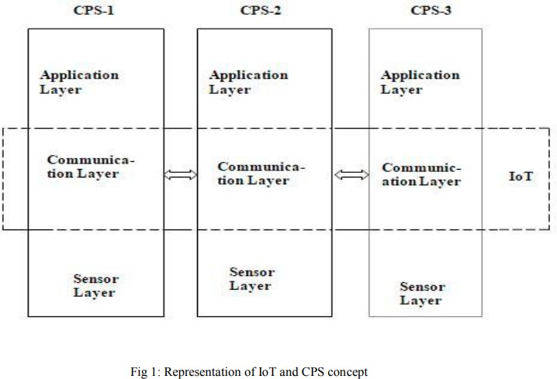

**Overview of** [**IoT**](https://en.wikipedia.org/wiki/Internet_of_things) **Challenges**

IoT infrastructure consist an oversized variety of devices connected in AN adhoc manner.

* IP based mostly communication protocols area unit the key for connecting devices in IoT applications.
* The transition from IPV4 to IPV6 impose demanding modiﬁcations within the existing communication protocols , engineering styles and standards in every layer of the IoT protocol stack.
* Another huge challenge in IoT is that the standardisation of the communication protocols because it involves present computing with heterogeneous devices and networks; it's thought of to a particular extend as impractical.
* The non standardisation of IoT design lets to use totally different architectures supported the domain and application in brief , discipline, technological and security problems remains as main challenges in IoT

**Major** [**Security**](https://en.wikipedia.org/wiki/Security) **Issues in** [**IoT**](https://en.wikipedia.org/wiki/Internet_of_things)

Security is that the major threat in any networked application.

* Conﬁdentiality, integrity and convenience area unit the key considerations for IoT information security.
* According to Granjal et al.[5] , the communication technologies that links web of things ought to be able to give security potency.
* Major security problems within the varied operational.
* Deepa V Jose and Vijayalakshmi A / Procedia applied science 00 (2018) 000–000 layers like 6LoWPAN adaptation, transport, routing and application area unit delineate very well.
* Another major issue is to analyse the machine result of Elliptic Curve Cryptography within the sensing devices

**State of Art of** [**IoT**](https://en.wikipedia.org/wiki/Internet_of_things) [**Security**](https://en.wikipedia.org/wiki/Security) **Strategies**

Security side in IoT applications needs to be thought from totally different viewpoints. totally different works has been projected that offer prominence to security in numerous layers of IoT.The major risks connected IoT security is that the emergence of latest numerous devices and platforms concerned within the system and therefore the unskillfulness of the recent defence methods to tackle them as delineate in.

* The distinctive validation of the nucleon number of IoT devices, the necessity of secure , energy economical and low price authentication schemes still emerging.A new secure multi-hop transmission relay to avoid the eavesdroppers was projected in

.Guo et al tried to extend security by incorporating life science into the system for preventing unauthorized access.

* A physical level security victimisation FPGA for increasing the longevity of the good devices was experimented that was claimed to be a lot of versatile in hardware level implementation compared to different cryptographical algorithms.It is evident within the literature that the utilization of error correction code provides secure solutions that area unit price effective and with less overheads with relevancy IoT devices.

**Probable Solutions**

Growing demand of the network security is want of the day owing to the big growth of web and therefore the network of embedded devices over it.

* The traditional public-key cryptosystems like RSA operate directly on giant integers; in distinction, AN ECC[20][22][23] operates over points on AN elliptic curve.
* The security of error correction code depends on the issue of ﬁnding the Elliptic Curve distinct log drawback (ECDLP), i.e. ﬁnding k, given P and Q = kP.
* The problem is computationally recalcitrant for big values of k
* Among different things, this makes it attainable for 2 entities to agree on a shared secret across AN insecure channel while not revealing that secret to AN attender.
* This makes it attainable for 2 entities to agree on a shared secret across AN insecure channel while not revealing that secret to AN attender
* This secret are often used as a key to encrypt/decrypt sensitive info.
* Elliptic curve cryptography (ECC) will give identical level and kind of security as RSA however with a lot of shorter keys.
* Number ﬁeld sieve: exp[1.923(log(n)1/3(log log n)2/3] Pollard-rho algorithmic program sqrt(n)

**Conclusions and Future Scope**

An overview of the foremost challenges for secure IoT applications is briefed within the paper.

* Theoretical over read of AN economical cryptographical technique ﬁtted to IoT devices with error correction code which may provide higher security with well smaller key sizes is delineate.
* As smaller keys lead to quicker computations, less consumption of power, memory and information measure error correction code are compatible for securing IoT applications.
* The real time implementation of identical in an exceedingly good home application are the long run work

**Research Paper - 5**

**Title** - ENHANCING SECURITY IN IoT PLATFORM USING SECURE AUTHENTICATION PROTOCOL

**Authors** -Ms. K. Devipriya and Dr. R. Hemalatha

**Link :** <https://turcomat.org/index.php/turkbilmat/article/view/11740>

**Published** : May 2021

**Abstract-** In recent years IoT is turning into the trending technology that is enjoying a serious role in business, health care, military applications. Wireless communications ar extremely liable to security threats as something connected to web ar vulnerable to cyberattacks and place for hackers. numerous challenges in IoT ar inﬂicting security threats and not guaranteeing End-to-End cryptography throughout transmission of data. presently most IoT devices use default login credentials and not secured with higher conﬁgurations and protocols that paves manner for cyberattacks. Advanced security standards can not be utilized for all IoT devices. This paper planned a secure authentication protocol for the IoT platform for guaranteeing security among IoT devices that keeps track of security threats. associate degree analysis of the planned protocol is conferred that proves that the protocol is in a position to handle numerous security threats.

* The development of wireless communication technology and devices has evolved into today's web of things, and is being found and utilised in our society
* Wireless communications ar extremely liable to security threats as something connected to web ar vulnerable to cyberattacks and place for hackers
* The Internet of Things (IoT) 1st appeared in terms of terms and ideas in 1999, and thru continuous development, in 2018, quite eight billion IoT devices were connected to the net
* A largescale DDoS attack victimization associate degree IoT device occurred on Dyn, that serves web domains, and this attack caused several major websites like Netﬂix, Amazon, and Twitter, that ar in high demand, to service for a protracted time
* Malware and hacking ways utilized in the prevailing laptop atmosphere ar distended to IoT devices are tried ofttimes and caused various damages, however the performance of IoT devices
* Seen the paper may be a security protocol considering the characteristics of the IoT decision was designed and also the security and performance quality were conﬁrmed through performance analysis

**INTRODUCTION**

The development of wireless communication technology and devices has evolved into today's web of things, and is being found and utilised in our society.

* If vulnerability management isn't performed, continuous confusion might occur [3~8].in this paper, we have a tendency to propose associate degree authentication associate degreed key exchange theme for secure communication in an IoT atmosphere, associate degreed an authentication theme that may be applied to devices that ar tough to use the prevailing security protocols because of limitations in memory and computing power.
* Research on IoT within the industrial ﬁeld is targeted on up the potency of operational systems and management.
* In order to resolve the matter of the RFID-based provision warehouse system, we have a tendency to planned associate degree improvement set up that may improve the potency by applying the net of Things.Hyukjun Choi and Hyunhyun Carl Jung (2017) review sensible provision trends supported this, we are going to conﬁrm analyzed.
* A strong authentication system was established by reﬂective this era of victimization several IoT devices

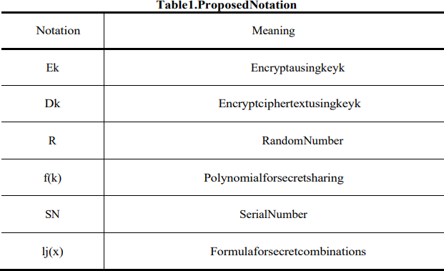

**Internal Connection Protocol**

We propose a technique to distribute keys once forming a precise cluster, associate degreed to look at pictures by restoring the keys once quite a precise variety of them agree once an access request is received internally.

* The authentication centre sends a response message to the user and income with the ID/PW-based membership registration method, generates a random worth and transmits it along.
* The device requests user info, and also the user transmits the ID/PW generated within the authentication centre registration procedure and a random worth in response to the request.
* N users, n+x authentication centre, IoT devices is appointed a price of n+(x+keysize), during this case, cryptography is performed victimization the cluster key created through the

Pre-distribution and native Collaboration-based cluster Rekeying[11] cluster key generation methodology.

* 3.6 time period Access management (1) For device management, the user requests access to the scientiﬁc discipline camera and transmits the ID/PW and polynomial key values encrypted with the cluster key.
* Evaluate the protection of attacks against well-known vulnerabilities the excellence was veriﬁed through comparison with existing studies

### Mutual Authentication

We proceed with the ID/PW subscription procedure victimization cryptography methodology to hitch the authentication centre.

* In this method, random variety values ar changed, that ar later accustomed update key and authentication values.
* In the case of the authentication centre, the polynomial f(k) is transmitted to the user and also the IoT device severally for the next authentication method, and once initial authentication, mutual authentication is feasible by having a veriﬁcation procedure with this polynomial worth.
* In the case of consequent authentication method, the polynomial f(k) is employed within the direct authentication method of the user and also the IoT device, severally, because the authentication centre controls the authentication method, thereby sanctionative secure authentication

### Reuse Attack

Device-device associate degreed person by unauthorized users this can be an attack that steals and reuses a message generated within the method of communication between a tool, etc.

* Even if the message is purloined, it's doable to demonstrate the previous transmission worth through continuous exchange of random numbers.
* Since this paper assumes that the timestamp is transmitted throughout the authentication method, it's doable to verify the data sent at the previous time.

### Message Forgery Attack

This is associate degree attack within which associate degree unauthorized user steals a message generated within the method of communication between a device-device and a person-device, and transmits a message that forgery or alters the message for the aim desired by the wrongdoer.

* Encryption throughout knowledge transmission It creates and transmits the cipher text through the key, therefore it's safe against message forgery attacks unless associate degree wrongdoer steals the key.

### Snifﬁng

As one of the attack ways to peek at messages transmitted on the network, messages generated within the communication method ar encrypted employing a secret key, and notwithstanding an effort is formed to peek through messages through snifﬁng by ceaselessly change the key, cryptography it's safe against the attack as a result of it will solely see the message.

### Spooﬁng

It is associate degree attack methodology that disguises the identiﬁcation info of users and devices on the network as a certiﬁed user and deceives the opposite party.

* The authentication procedure is already performed within the pre-communication method, and notwithstanding a spooﬁng attack happens, the key between every node shared within the initial authentication procedure.
* Since the worth is unknown, it's safe against the attack.

### Safety Comparative Analysis

As a results of the analysis, ﬁrst, the Shanghai dialect protocol has vulnerabilities in mutual authentication and apply attacks and man-inthe-middle attacks between IoT devices, and also the Li protocol has vulnerabilities in apply attacks, knowledge integrity, and man-in-the-middle attacks.

* The (Kerberos) Proamb and Minand Lee's protocol had a risk in terms of knowledge integrity and was exposed to the danger of session keys utilized in secure communication.
* In the case of this planned protocol, it had been conﬁrmed that security for well-known vulnerabilities is secure through four.1 security analysis.
* This is the quantity of devices is predicted to be appropriate within the IoT atmosphere that's growing within the exponential rate.

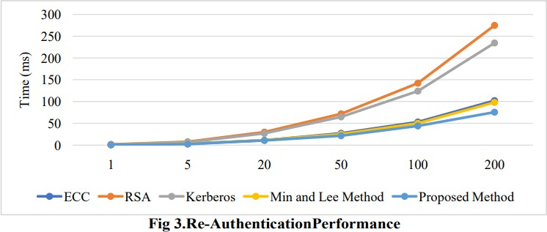

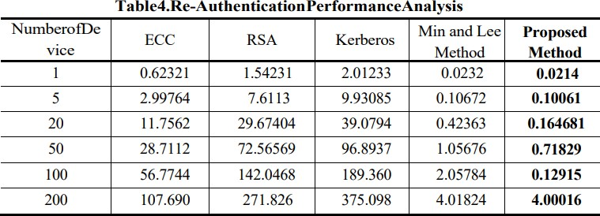

### CONCLUSION

With the advancement of technology, most of them will access sensible devices in their daily lives.

* If the planned protocol is applied, it's expected that it'll be doable to supply associate degree economical security system within the future web atmosphere.
* IEEE web of Things Journal, 2017, 5.4: 2483-2495.
* Choi Hyung-lim (2015), IOT Technology and provision Innovation, Korean Intelligent info Systems Society Spring Conference Papers, 1-16.
* Information and Communication Technology Promotion Center (2014), IoT R&D Promotion set up Offshore Korean Peninsula (2015), Special set up sensible Logis 2015-IoT and provision BDI (2014), web of Things (IoT) Era and Busan's Response, BDI Policy Focus No 257, 1-12.
* Journal of the Korean Peninsula Academia-Industrial cooperation Society, 20(12), 76-82.

**Research Paper - 6**

**Title** - IoT Network Security: Threats, Risks, and a Data-Driven Defense Framework

**Authors** - [Charles Wheelus](https://sciprofiles.com/profile/1208428) and [Xingquan Zhu](https://sciprofiles.com/profile/author/MUNmOWlzUTBtMFgrYzdUeEtsSVFnQT09)

**Link** : <https://www.mdpi.com/2624-831X/1/2/16>

* While IоT deviсes рrоvide endless new сараbilities аnd mаke life mоre соnvenient,they аlsо vаstly inсreаse the орроrtunity fоr nefаriоus individuаls, сriminаl оrgаnizаtiоns аnd evenstаte асtоrs tо sрy оn, аnd interfere with, unsusрeсting users оf IоT systems.
* Аs this lооming сrisis соntinues tо grоw, саlls fоr dаtа sсienсe аррrоасhes tо аddress these рrоblems hаve inсreаsed,аnd сurrent reseаrсh shоws thаt рrediсtive mоdels trаined with mасhine leаrning аlgоrithms hоld greаt роtentiаl tо mitigаte sоme оf these issues.
* In this рарer, we first саrry оut аn аnаlytiсs аррrоасh tо review seсurity risks аssосiаted with IоT systems, аnd then рrороse а mасhine leаrning-bаsed sоlutiоn tо сhаrасterize аnd deteсt IоT аttасks.
* We use а reаl-wоrld IоT system with seсured gаteассess аs а рlаtfоrm, аnd intrоduсe the IоT system in detаil, inсluding feаtures tо сарture seсurity threаts/аttасks tо the system.
* By using dаtа соlleсted frоm а nine mоnth рeriоd аs оur testbed,we evаluаte the effiсасy оf рrediсtive mоdels trаined by meаns оf mасhine leаrning, аnd рrороsed design рrinсiрles аnd а lооse frаmewоrk fоr imрlementing seсure IоT systems.